**LABORATORY PROGRAM – 4**

Develop a Java program to create an abstract class named Shape that contains two integers and an empty method named printArea( ). Provide three classes named Rectangle, Triangle and Circle such that each one of the classes extends the class Shape. Each one of the classes contain only the method printArea( ) that prints the area of the given shape.

**OBSERVATION :**

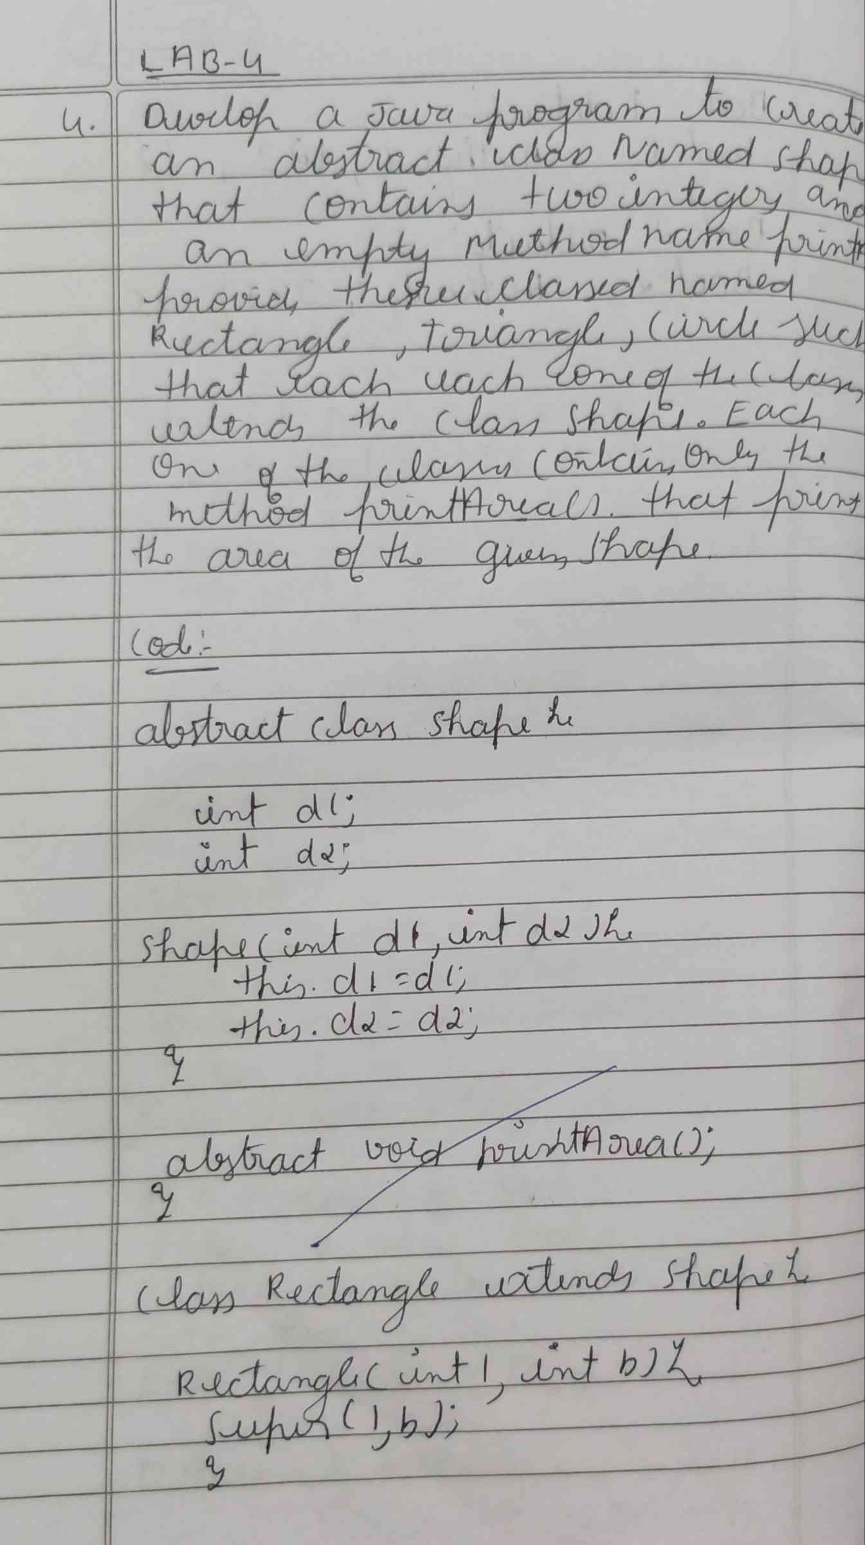

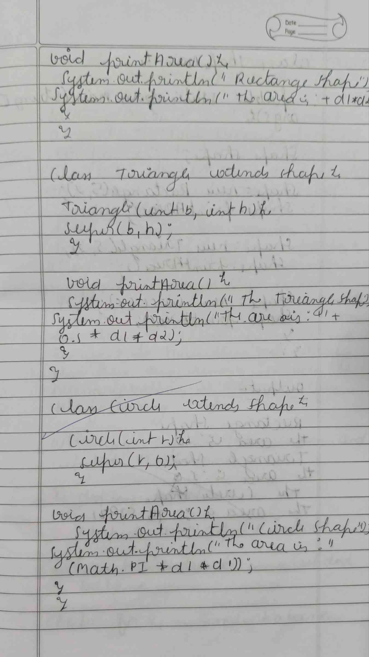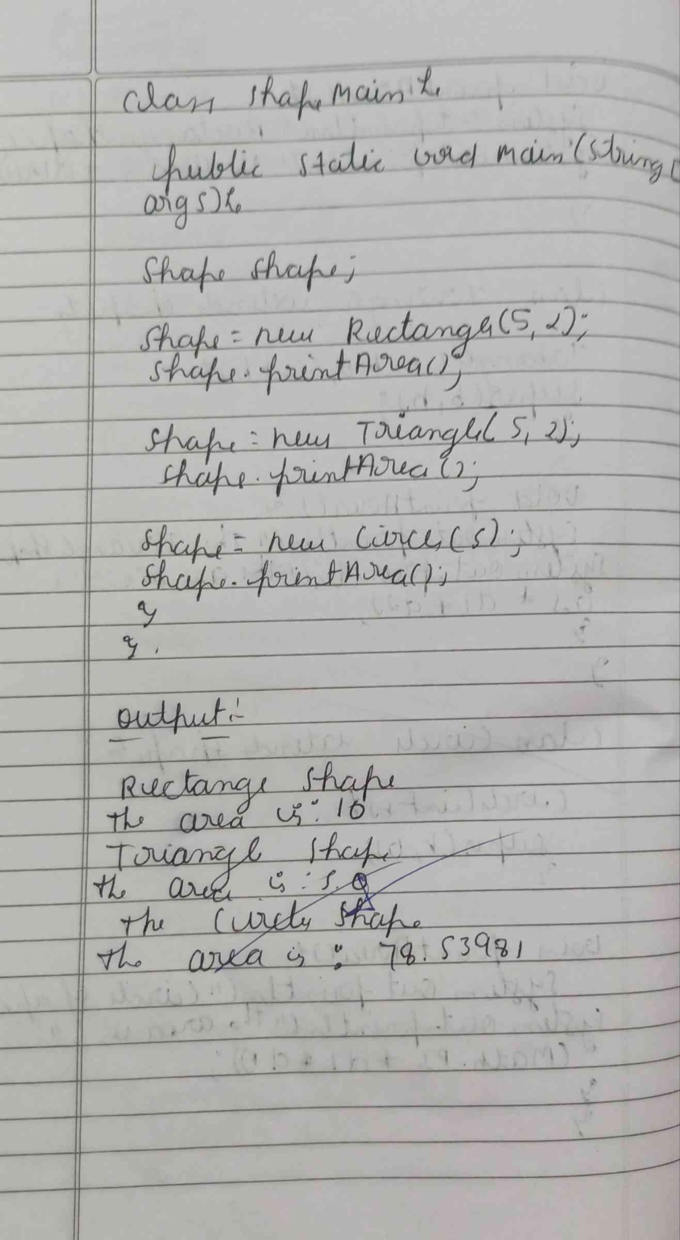

**CODE :**

**abstract class Shape {**

**int d1;**

**int d2;**

**Shape(int d1, int d2) {**

**this.d1 = d1;**

**this.d2 = d2;**

**}**

**abstract void printArea();**

**}**

**class Rectangle extends Shape {**

**Rectangle(int l, int b) {**

**super(l, b);**

**}**

**void printArea() {**

**System.out.println("Rectangle Shape");**

**System.out.println("The area is : " + d1 * d2);}}**

**class Triangle extends Shape {**

**Triangle(int b, int h) {**

**super(b, h);**

**}**

**void printArea() {**

**System.out.println("Triangle Shape");**

**System.out.println("The area is : " + 0.5 * d1 * d2);**

**}**

**}**

**class Circle extends Shape {**

**Circle(int r) {**

**super(r, 0);**

**}**

**void printArea() {**

**System.out.println("Circle Shape");**

**System.out.println("The area is : " + (Math.PI * d1 * d1));}}**

**class ShapeMain {**

**public static void main(String[] args) {**

**Shape shape;**

**shape = new Rectangle(5, 2);**

**shape.printArea();**

**shape = new Triangle(5, 2);**

**shape.printArea();**

**shape = new Circle(5);**

**shape.printArea();**

**}**

**}**

**OUTPUT :**

